Eating Out Habits and Health Awareness

Introduction
With the rise of busy lifestyles and food delivery applications, eating outside food has become increasingly common. This project aims to analyze eating-out habits across different age groups and understand their impact on lifestyle, spending patterns, and health awareness.

Data Collection & Methodology
Data was collected from 20 respondents belonging to different age groups and professions using a Google Form survey. The questionnaire covered eating-out frequency, food preferences, health concerns, and monthly spending. The responses were exported to Excel, cleaned, and analyzed using Pivot Tables, formulas, and charts.

Key Findings
- The 18–25 age group eats outside food more frequently than other age groups.
- Food delivery apps and restaurants are the most preferred sources of outside food.
- Around 60% of respondents are concerned about the health impacts of eating outside.
- The average monthly spending on eating outside food is approximately ₹2,500–₹3,000.
- Frequent eating out is associated with issues such as weight gain and digestion problems.
Refer this Excel: https://docs.google.com/spreadsheets/d/1WwlDehhPH4IcO5MGfP9qMZI1EiV0uu_Pb2Em2tqv1og/edit?usp=sharing

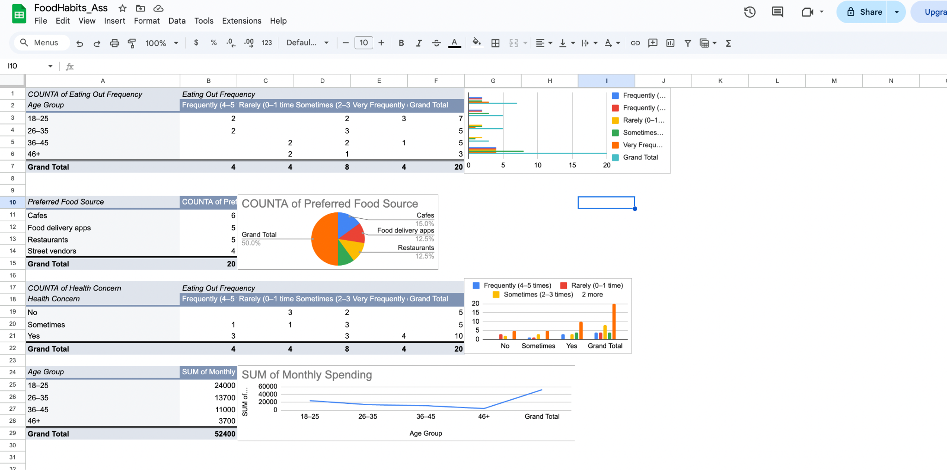

Observations
- Younger individuals prioritize convenience over health.
- Older age groups prefer homemade food and eat outside less frequently.
- Increased eating-out frequency leads to higher spending and greater health concerns.

Suggestions
- Encourage healthier food choices when eating outside.
- Limit fast food consumption and increase home-cooked meals.
- Promote awareness of budgeting and long-term health effects.

Conclusion
The study concludes that while eating outside food is convenient, excessive dependence can negatively impact health and finances. Adopting mindful eating habits can help maintain a balanced and healthy lifestyle.

